**Can migratory** **birds spread avian haemosporidian parasites?**

Daniela de Angeli Dutra¹*, Antoine Filion¹, Alan Fecchio², Érika Martins Braga³, Robert Poulin¹

[danideangeli@live.com*](mailto:danideangeli@live.com*) https://orcid.org/0000-0003-2341-2035

[afilion90@gmail.com](mailto:afilion90@gmail.com) https://orcid.org/0000-0003-1198-3017

[alanfecchio@gmail.com](mailto:alanfecchio@gmail.com) https://orcid.org/0000-0002-7319-0234

[embraga@icb.ufmg.br](mailto:embraga@icb.ufmg.br) <https://orcid.org/0000-0001-5550-7157>

[robert.poulin@otago.ac.nz](mailto:robert.poulin@otago.ac.nz) https://orcid.org/0000-0003-1390-1206

1.Department of Zoology, University of Otago, Dunedin, New Zealand

2.Programa de Pós-graduação em Ecologia e Conservação da Biodiversidade, Universidade Federal de Mato Grosso, Cuiabá, MT 78060-900, Brazil

3.Departamento de Parasitologia, Instituto de Ciências Biológicas, Universidade Federal de Minas Gerais, Brazil

**\*Correspondence:**

Daniela de Angeli Dutra

danideangeli@live.com

**Abstract:**

**Aim:** Migration has an important impact on the transmission of pathogens. Migratory birds disperse parasites through their routes and may consequently introduce them to new areas and hosts. Hence, haemosporidian parasites, which are among the most prevalent, diverse, and important bird pathogens, are potentially dispersed when infecting migrant hosts. Here, we hypothesize and aim to evaluate if (1) migratory birds spread parasite lineages along their routes, and (2) localities crossed by more migratory birds have greater prevalence and richness of haemosporidians.

**Location:** South America

**Taxa:** Avian haemosporidian parasites

**Method**s: For the first hypothesis, we tested whether parasite lineages found (i) only in migratory birds, (ii) in both migrants and residents, and (iii) only in residents, differ in their frequencies of occurrence among localities. For the second hypothesis, we tested for a relationship among localities between the overall local haemosporidian parasite richness and prevalence, and the proportion of migratory bird individuals present in a locality. We combined a dataset on 13200 bird samples with data from the MalAvi database (~2800 sequenced parasites comprising 675 distinct lineages, from 506 host species and 156 localities), and used Bayesian multi-level and mixed models to test our hypotheses.

**Results:** We demonstrate that parasites shared between resident and migratory species are the most widespread, demonstrating the potential of migrant to carry and transmit haemosporidians. Further, the presence of migrants in a locality was negatively related to local parasite richness, but not associated with local prevalence.

**Conclusion:** We confirm that migrants can contribute to parasite dispersal, however, bird migration and visiting migrants do not raise local prevalence and may decrease richness of avian haemosporidians, probably due to local constraints on transmission like environmental filtering or incompatibility between haemosporidian lineages and their vectors.

1.Introduction

Migration has an important impact on the transmission of disease across the world as migrant species disperse pathogens and parasites between localities, while also being exposed to more infectious agents (Bartel, Oberhauser, De Roode, & Altizer, 2011; Bauer & Hoye, 2014; Teitelbaum, Huang, Hall, & Altizer, 2018). In this way, migrant species might play an important role in the evolution and distribution of parasites and promote the spread of pathogens to new areas and new hosts species. At the same time, human-introduced pathogens and host species can decrease the fitness and survival of resident and native species, compromising the population abundance of local species and reducing community richness (Callaway & Ridenour, 2004; Prenter, MacNeil, Dick, & Dunn, 2004). Conversely, the spread of pathogens might increase host richness by reducing local competition pressures and, consequently, preventing competitive exclusion. Hence, pathogen spread might act as an environmental filter to new species colonization. Recent studies have demonstrated that migratory birds harbor a greater diversity of parasites than resident species (Gutiérrez, Piersma, & Thieltges, 2019; Koprivnikar & Leung, 2015). In addition, several studies have documented the influence of migratory birds on the spread of important pathogens (Hellgren et al., 2007; Morshed et al., 2005; Ricklefs et al., 2017) with some of these able to infect humans (Lindeborg et al., 2012; Morshed et al., 2005; Poupon et al., 2006). Thus, the migratory behavior of birds may influence directly host local richness and population size.

Avian malaria parasites and related haemosporidians, could be used as geographical markers for migratory birds (Marzal, 2012). Previous research has demonstrated differences in the timing of the main occurrence of haemosporidian infection in migrating birds. These studies have suggested that differences in haemosporidian lineages harbored could indicate whether birds had become infected in different areas (Marzal, 2012). Since most haemosporidians cause life-long infections (Valkiūnas, 2005), parasites may travel across long distances with their bird host during migration, allowing them to infect new vectors and new avian hosts in novel environments. Indeed, migratory species are known for their potential to connect distant habitats and transfer large amounts of biomass, nutrients and other organisms between ecosystems (Bauer & Hoye, 2014). Furthermore, O’Connor et al. 2020 have demonstrated that migratory birds do not possess higher immune gene richness in wetter areas, which jointly with temperature is one of the main climatic factors that influence haemosporidian prevalence (Illera, López, García-Padilla, & Moreno, 2017). Thereby, migratory birds may be more susceptible to pathogens in those regions. For this reason, it might also be expected that migratory birds harbor a more diverse range of parasites and might be more susceptible to parasite infections.

South America comprises different types of biomes, which hold a great richness of native resident and migratory bird species, thus making it an ideal system to investigate such questions. Moreover, prevalence of *Plasmodium,* which is the most prevalent haemosporidian in this region,can be markedly different between South America regions (Braga, Silveira, Belo, & Valkiunas, 2011). *Plasmodium* parasites present higher host-shifting rates than other bird haemosporidians (Hellgren et al., 2007), which could certainly contribute to their increased dissemination by migratory birds into new areas. Indeed, host-shifting of a *Plasmodium* species from domestic chicken to wild and native birds has already been reported in South America (Ferreira-Junior et al., 2018).

Furthermore, the great avian richness (~3500 species) and abundance in South America (Remsen et al., n.d.) could also enhance the probability of parasite host-shifting between migratory and resident birds, given the likely presence of susceptible birds in any particular area. Besides that, the great richness and abundance of vectors (Consoli & Oliveira, 1994; Santiago-Alarcon, Palinauskas, & Schaefer, 2012) could also increase the chances of host-shifting between migratory and resident birds as it increases the chances of compatible vectors being present. Thus, these features make the South American avian haemosporidians a great model system to investigate the putative transmission of pathogens via host migration in nature.

In this context, the main goal of this study is to evaluate the influence of migratory birds on the spread of haemosporidian parasites in South America. Specifically, we evaluated the hypothesis that (1) migratory birds spread parasite lineages along their migratory routes, and (2) localities crossed by more migratory routes have greater prevalence and richness of haemosporidian lineages. For the first hypothesis, we tested whether parasite lineages found (i) in both migrants and residents and (ii) only in residents, differ in their geographical range. Due to the fact migrants can carry parasites from many sites and potentially infect resident birds, we predicted that parasite lineages using migratory birds should occur in a greater range than those using only resident birds. Moreover, migration behavior increases the exposure of birds to more parasite lineages and hence their contact with different parasites as migrants are present in regions that harbor different parasite communities. Therefore, we expect higher haemosporidian richness and prevalence in regions with more migratory birds. For the second hypothesis, we tested for a relationship among localities between the overall local haemosporidian parasite richness and prevalence, and the proportion of migratory birds present in a locality. Our analysis also takes into account other potential drivers of haemosporidian prevalence and species richness, such as temperature and precipitation, which influence the local abundance of vectors.

2. Methods

2.1 Dataset

All analyses were performed using a dataset comprising ~13200 bird blood samples accounting for 916 species from 63 different localities sampled from 2005 to 2018 in South America, with a subset of those samples previously used in Fecchio, Bell, et al., 2019; Ferreira-Junior et al., 2018; Ferreira et al., 2017; Lacorte et al., 2013, and supplemented with new, previously unpublished data (See Supplementary Table 1). In addition to this dataset, we extracted haemosporidian lineages from the MalAvi database (<http://130.235.244.92/Malavi/>, Bensch et al. 2009) including data from the South American region extracting the information from the Grand Lineage Summary after filtering the data obtained from our first dataset (Figure 1). Combining both datasets, we obtained a total of ~2800 sequenced parasites representing 675 distinct lineages collected from 506 different host species and 156 localities (all lineages belonging to one of these three genera: *Plasmodium*, *Haemoproteus* and *Leucocytozoon*). Each locality was assigned to a biome based on the classification of Turchetto-Zolet et al. 2013. The parasite prevalence per bird species and locality was estimated using PCR diagnostic protocols described by Hellgren et al. 2004, Fallon et al. 2003, and Bell et al. 2015. The parasite lineages were sequenced by the PCR protocol described by Hellgren et al. 2004 and identified by comparing the sequences with the ones deposited in MalAvi and GenBank (https://www.ncbi.nlm.nih.gov/genbank/). This protocol produces a *cyt b* fragment of 478 bp. The birds present in each locality were classified into three ecological classes: (1) resident; (2) partial migrant and (3) full migrant, according to the Brazilian Committee of Ornithology Records - CRBO 2014, Somenzari et al. 2018 and BirdLife International (<https://www.birdlife.org/>).

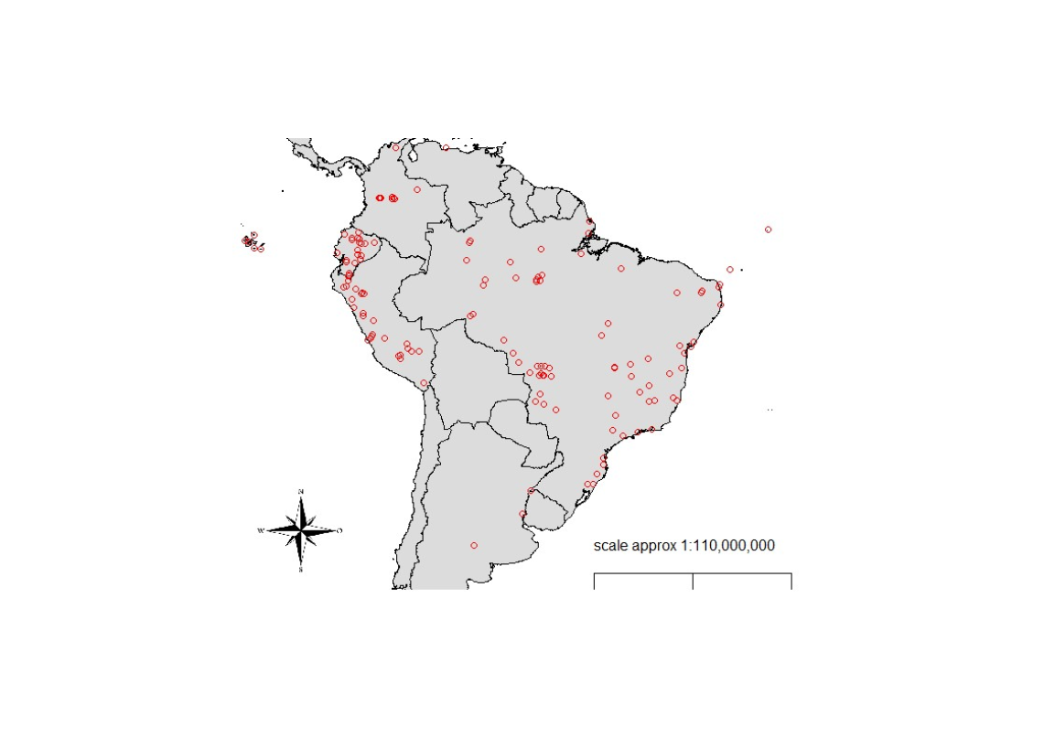

Figure 1: Bird collection localities. Collection localities comprise a total of 156 localities (including offshore islands) combining our dataset and the MalAvi database.

2.2 Statistical Analyses

All analyses were conducted in R version 4.02 (R Core Team, 2019). Aiming to evaluate the potential impact of locality, phylogenetic and climate in our models we calculate spatial autocorrelation, phylogenetic signal and extracted climate data from Worlclim (see supplementary material). The spatial autocorrelation analyses revealed there was no substantial effect of space on parasite richness (Moran Index = -0.0007), however, for prevalence, we observed Moran Index of 0.15 which was also different than the null expectation. For this reason, biome and locality was used as random effects in our second Bayesian and mixed models to control for idiosyncratic characteristics of localities. Likewise, considerable phylogenetic signals were observed among bird for prevalence (0.49) and parasite richness (0.17) and, therefore, we employed avian phylogeny in the second of the Bayesian model.

*Bayesian models*

In order to determine whether migratory birds spread parasite lineages along their migratory routes and to evaluate the parasite connectivity among localities due to migratory behavior, we used multi-level modeling (MLM) with the “brms” package (Bürkner, 2017) to evaluate the geographical range in which haemosporidian lineages occurred depending on whether they were found only in resident birds or in both residents and migrants. We decided to use Bayesian modelling as it allows us to statistically estimate the geographical range among which lineages are distributed according to their host status. Naturally, for parasites to be dispersed by migrant hosts, they need not only to be moved around by migratory hosts, but also infect the resident community. Hence, we compared the geographic range of parasites found in resident birds only and the parasites shared by resident and migratory host species. However, for this last group, we accounted only for the localities where lineages were infecting both resident and migrant hosts as only when the parasite is also present in the resident community there is evidence of parasite dispersal.

Aiming to understand the variation of geographical range (estimated by minimum spanning tree distance - i.e. total distance of all lines connecting each locality minimized, see supplementary material) in which each lineage was present, we decided to build a single model including the migratory status of hosts used by a lineage (categorical variable with four levels: resident, partial migratory and resident, full migratory and resident, and both partial/full migratory and resident; reference category = resident) while also controlling for sample size and number of host species used by a lineage. We also performed a second model comparing lineages present in resident only and lineages present in resident plus any migratory category. Then, we considered geographical range as our dependent variable and migratory status of hosts used by a lineage as our independent variable. We chose our priors using the “get_prior” function. As our response variable was a continuous skewed data, we applied the Gamma distribution family, using 4 chains with MCMC 4000 total iterations per chain (2000 for warmup, 2000 for sampling). The model results were plotted using the “conditional_effects” function to visualize the predictions of the host migratory status effects. We ran three models per analyses: one for all three parasite genera combined, one for *Plasmodium* lineages only, and one for *Haemoproteus* lineages only.

In the next model, we analysed the prevalence of infection in each bird species among localities. For this, we considered local number of infected individuals out of the total sample per locality as our dependent variable, and local proportion of migratory bird individuals (i.e., proportion of migratory individuals, including both partial and full migrants, out of all individual birds sampled in a locality) as our independent variable. In addition, we used only our original dataset and excluded the data from the MalAvi database, since the latter presents only positive and sequenced samples. Thus, our analyses were based in 142 bird species distributed among 63 localities. Also, in this model, we grouped the dataset per bird species and localities and we filtered our data in order to include only species with 10 or more bird individuals analysed. Negative binomial distribution was applied in this model account for the overdispersion of our prevalence data, thus avoiding production of biased estimates. We used 4 chains with MCMC 4000 total iterations per chain (2000 for warmup interactions, 2000 for sampling). Indeed, we firstly evaluated if host richness (i.e., number of bird species sampled per locality, log-transformed scaled value), parasite richness (log-transformed scaled value), proportion of migratory species (log-transformed scaled value), number of migrant individuals (log-transformed scaled value), temperature (log-transformed scaled value) and precipitation had significant effects on bird prevalence. Following these analyses, only proportion of migratory bird individuals and parasite richness were retained as fixed factors. Further, we considered biome and locality as a random variables and also used the function “cov_ranef” to account for phylogenetic influence. The model results were plotted using the “conditional_effects” function to visualize the predictions of our independent variable. Again, we ran three models: one for all three parasite genera combined, one for *Plasmodium* lineages only, and one for *Haemoproteus* lineages only; in these last two models we considered zero inflated negative binomial distribution.

*Mixed model*

A mixed model was performed to estimate whether localities with more migratory birds have greater prevalence and richness of haemosporidian lineages. We considered parasite richness as our dependent variable and proportion of migratory individuals per locality (N=63 localities) as our and independent variable. Here, we also used only our original dataset. In this model, we did not use data from the MalAvi database, but only our dataset described above since it provides more information regarding the localities, such as prevalence data and host richness. We firstly tested our variables for normal distribution and created models including variables that presented an effect on our dependent variable, and then selected the best model among them using the Akaike information criterion (AIC). We used generalized linear mixed model applying the “glmer” function from the “lme4” package (Bates, Maechler, Bolker, & Walker, 2015) applying Poisson distribution. For this, we considered local host richness (log-transformed scaled value), prevalence across all birds sampled (log-transformed scaled value), proportion of migratory species (log-transformed scaled value), number of migrant individuals (log-transformed scaled value), temperature (log-transformed scaled value) and precipitation as fixed variables. Biome and locality was set as random intercept. We ran three models: one for all three parasite genera combined, one for *Plasmodium* lineages only, and one for *Haemoproteus* lineages only.

3. Results

Our first Bayesian model analyses revealed the lineages shared by resident and full migratory species are the most widespread spatially, as they are found in a higher geographical range (Figure 2, Table 1). However, we observed that the lineages shared by only resident and other migratory category (partial migrant and partial plus full migrant) and residents are as widespread as the lineages present in only resident hosts (Figure 3, Table 2). However, when analysing both parasite genera separately no difference was observed in the geographical range (Figure S1, Figure S2, Table S2 and Table S3). Nevertheless, when repeating these analyses combining all lineages present in resident and migrants together, we observed lineages shared by migrant and resident presents the highest geographical range. Indeed, when analysing separately for the two main parasite genera, we observed distinct patterns of distribution for *Plasmodium* and *Haemoproteus* lineages. For *Haemoproteus* no difference was observed in the geographical range between the lineages categories, while for *Plasmodium* linages also present in migrants were more spread (Figure S3, Figure S4, Table S4 and Table S5).

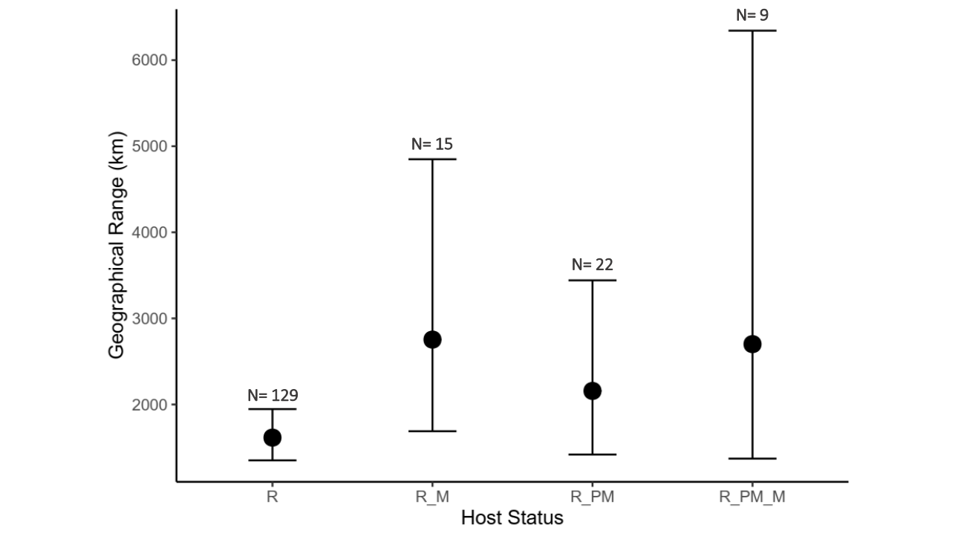

Figure 2: Mean (±confidence intervals) geographical range in kilometers in which haemosporidian lineages are detected according to the type of birds in which they are found. M = full migratory, PM = partial migratory, R = resident, R_M = resident and full migratory, R_PM = resident and partial migratory and R_PM_M = resident, partial migratory and full migratory. Number of lineages in each of the four categories are shown on the graph.

Table 1: Parameter estimates, standard errors, and confidence intervals for the Bayesian model testing the differences in the geographical range of haemosporidian lineages among those that occur in migratory and/or resident avian host species.

|  |  |  |  |  |
| --- | --- | --- | --- | --- |
|  | **Estimate** | **Std. error** | **Conf. Inter (95%)** | |
| Intercept | 7.20 | 0.12 | 6.87 | 7.33 |
| Resident and full migrant | 0.54 | 0.29 | 0.00 | 1.13 |
| Resident and partial migrant | 0.29 | 0.24 | -0.17 | 0.79 |
| Resident, partial and full migrant | 0.53 | 0.41 | -0.21 | 1.41 |
| Number of bird individuals | 0.00 | 0.01 | -0.02 | 0.03 |
| Number of host species per lineage | 0.05 | 0.03 | -0.01 | 0.11 |

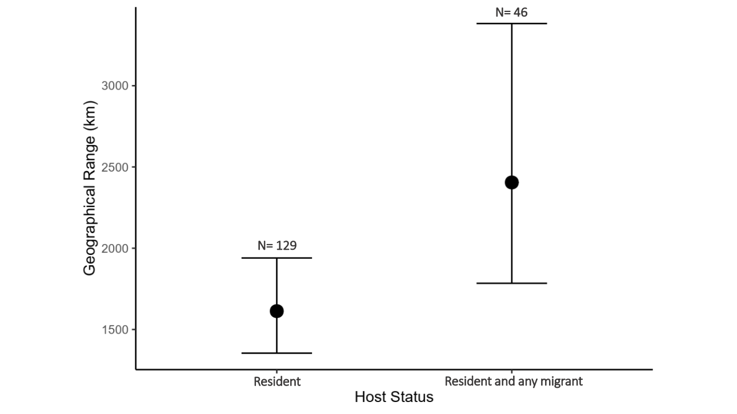

Figure 3: Mean (±confidence intervals) geographical range in kilometers in which haemosporidian lineages are detected according to the type of birds in which they are found. Number of lineages in each of the four categories are shown on the graph.

Table 2: Parameter estimates, standard errors, and confidence intervals for the Bayesian model testing the differences in the geographical range of haemosporidian lineages among those that occur in migratory and/or resident avian host species.

|  |  |  |  |  |
| --- | --- | --- | --- | --- |
|  | **Estimate** | **Std. error** | **Conf. Inter (95%)** | |
| Intercept | 7.10 | 0.11 | 6.88 | 7.32 |
| Resident and any migrant | 0.40 | 0.19 | 0.05 | 0.79 |
| Number of bird individuals | 0.00 | 0.01 | -0.02 | 0.03 |
| Number of host species per lineage | 0.05 | 0.03 | -0.01 | 0.11 |

For the next Bayesian model, in which we analysed the relationship between local prevalence per bird species and local proportion of migratory bird individuals, we observed no correlation between the relative occurrence of migrants and prevalence of haemosporidian parasites per species (Figure S5, Table S6). However, when we repeated the analysis separately for only *Plasmodium* or *Haemoproteus* lineages, we observed negative and positive relationships between local percent of migrants and number of positive birds per locality, respectively (Figure 4 and 5, Table 3 and 4). Parasite richness had a significant positive effect on prevalence per bird species, whether when considering all haemosporidian lineages (Table S6), or *Haemoproteus* lineages (Table 4).

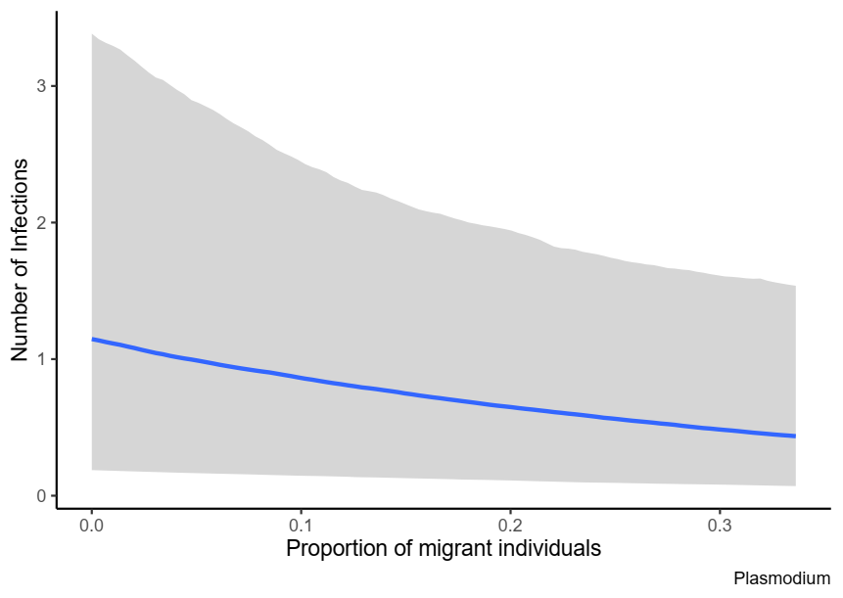

Figure 4: Correlation between local number of infections of *Plasmodium* parasites and proportion of migratory host individuals per locality. We observed negative effect of the proportion of migratory individuals on parasite prevalence.

Table 3: Parameter estimates, standard errors, and confidence intervals for the Bayesian model testing the variation of local *Plasmodium* prevalence as a function of the proportion of migratory individuals out of all individual birds sampled per locality and parasite richness.

|  |  |  |  |  |
| --- | --- | --- | --- | --- |
|  | **Estimate** | **Std. error** | **Conf. Inter (95%)** | |
| Intercept | -0.47 | 0.77 | -2.07 | 0.87 |
| Proportion of migrant individuals | -2.78 | 1.40 | -5.58 | 0.07 |
| Parasite Richness | 0.02 | 0.01 | -0.01 | 0.04 |

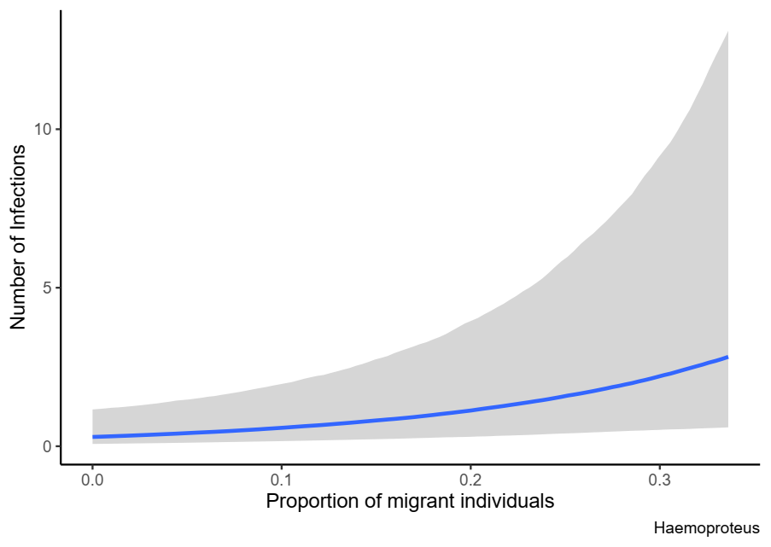

Figure 5: Correlation between local number of infections of *Haemoproteus* parasites and proportion of migratory host individuals per locality. We observed positive effect of the proportion of migratory individuals on parasite prevalence.

Table 4: Parameter estimates, standard errors, and confidence intervals for the Bayesian model testing the variation of local *Haemoproteus* prevalence as a function of the proportion of migratory individuals out of all individual birds sampled per locality and parasite richness.

|  |  |  |  |  |
| --- | --- | --- | --- | --- |
|  | **Estimate** | **Std. error** | **Conf. Inter (95%)** | |
| Intercept | -2.37 | 0.84 | -4.07 | -0.76 |
| Proportion of migrant individuals | 6.78 | 2.30 | 2.40 | 11.37 |
| Parasite Richness | 0.04 | 0.02 | 0.01 | 0.07 |

Our mixed model examining the influence of migrants on parasite richness revealed no differences depending on whether we considered both haemosporidian genera together or separately. The Akaike information criterion revealed that the best model set considered only local host richness, prevalence across all birds sampled, proportion of migratory species, number of migrant individual and temperature as fixed factors (Table S7). Our first mixed model revealed that there is no effect of the proportion of migratory bird individuals per locality on local parasite richness (Figure 6, Table 5). However, we observed a negative relation between the proportion of migratory species and parasite richness. Further, we also observed no effect of the proportion of migratory bird individuals on local parasite richness for *Plasmodium* and *Haemoproteus* infections when the two genera were treated separately (Figure S6 and S7, Table S8 and S9). However, proportion of migratory species was also negatively correlated to *Haemoproteus* lineage richness, however, the total number of migrants presented the opposite pattern. Moreover, we observed positive effects on parasite richness of other two predictors in all models: local host richness and overall local prevalence.

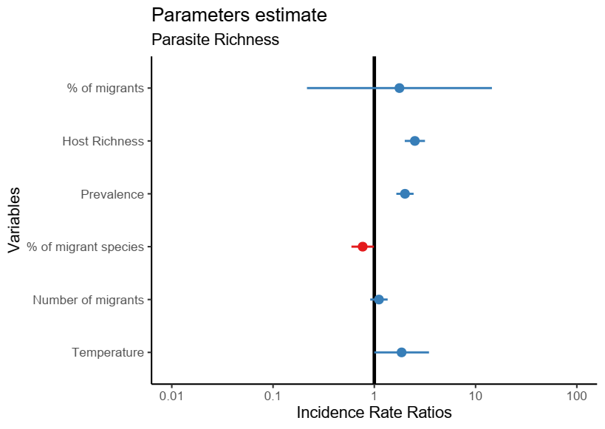

Figure 6: Parameters estimates as a function of parasite richness. No correlation was found between the proportion of migratory individuals and haemosporidian richness.

Table 5: Parameter estimates, standard errors, z and p values for the mixed model testing the variation of local haemosporidian richness as a function of the proportion of migratory individuals out of all individual birds sampled per locality, as well as other predictors.

|  |  |  |  |  |
| --- | --- | --- | --- | --- |
|  | **Estimate** | **Std. error** | **Z** | **P** |
| Intercept | -6.16 | 1.71 | -3.60 | <0.001 |
| Proportion of migrant individuals | 0.57 | 1.07 | 0.53 | 0.59 |
| Host richness | 0.92 | 0.12 | 7.87 | <0.001 |
| Prevalence | 0.70 | 0.10 | 6.97 | <0.001 |
| Proportion of migrant species | -0.26 | 0.13 | -2.03 | 0.04 |
| Number of migrants | 0.11 | 0.10 | 1.04 | 0.30 |
| Temperature | 0.62 | 0.32 | 1.95 | 0.05 |

**4. Discussion**

Animal migrations can play important roles in both the geographical dispersal of disease agents, and in the local epidemiology of diseases for both resident and migratory species (Bauer & Hoye, 2014; Bradley & Altizer, 2005; Teitelbaum et al., 2018). Here, we demonstrated that some migratory birds may disperse parasite lineages through their migratory routes, such that lineages infecting both migrants and residents are more widespread. Despite migration leading to lineages dispersing across South America, we did not observe higher prevalence of infection in localities with higher proportions of migratory birds. Nevertheless, we observed different patterns for *Plasmodium* and *Haemoproteus* parasites, such that *Plasmodium* prevalence negatively correlated with increasing proportion of migrants, whereas *Haemoproteus* prevalence was higher in the presence of migrants. Moreover, haemosporidian richness decreased as the proportion of migratory species rose across localities. However, parasite richness also seems to be positively related to local host richness and prevalence. Thus, migrant birds could potentially influence the ecology and evolution of haemosporidian dispersal in South America leading to an increase in parasite spread and influencing parasite prevalence, composition, and richness.

Further, parasites infecting only resident and partial migrant or full and partial migrant birds were present in a similar geographical range as those infecting only resident avian hosts. We believe insufficient sampling of certain migrant avian species in many areas could have led to the low geographical range in which lineages infecting only resident and partial and full and partial migrant birds were found. In addition, we also demonstrate that generalist parasites may be more successful in colonizing new regions since only parasites that infected residents and migrant hosts present greater geographic distributions.

Dispersal of haemoporidians might be an important step toward parasite diversification for local community composition since parasites, after establishing in new regions, can evolve into new and distinct parasite lineages (Ellis et al., 2019; Fecchio, Bell, et al., 2019). Indeed, Ellis et al. (2019) demonstrated that South America presents the greatest proportion of sympatric nodes for *Plasmodium* spp. and one of the greatest *Haemoproteus* diversification rates, indicating high rates of parasite diversification in this region. Hence, considering the potential contribution of migrant birds toward parasite dispersal, these hosts might play a fundamental role in parasite evolution and diversification in South America. Indeed, many species migrate during the breeding season and relapses (increases in parasite intensity circulating in the host) mainly occur after this period (Valkiūnas, 2005), thus facilitating parasite dispersal to new regions. However, we did not observe a clear relation between the presence of migrant birds and local haemosporidian prevalence since our data suggests that *Plasmodium* and *Haemoproteus* parasites respond differently to the presence of migrant host. The fact that most of our lineages were observed only in resident birds could explain the lack of a relationship between avian migrants and haemosporidian prevalence, since the greatest haemosporidian diversity occurs in resident avian species. In addition, Hellgren et al. (2007) also suggest that new haemosporidian introductions into resident bird faunas are not common evolutionary events. Moreover, we observed that other factors such as host richness and overall local prevalence also influence parasite prevalence. Therefore, it seems environmental and host features could be more important in determining local parasite richness than dispersal patterns.

It is worth mentioning that distinct parasite taxa can respond differently to the presence of migrant hosts. As we reported in this study, despite the fact no relation was observed for general haemosporidian prevalence, *Plasmodium* and *Haemoproteus* presented contrasting responses to an increase in the local proportion of migrant individuals. Whereas *Plasmodium* prevalence was negatively correlated to an increase of migrants in the local bird community, we observed a rise in *Haemoproteus* infections. Such behavior illustrates that different pathogens do not respond identically to host migratory behavior. Indeed, previous research has documented different effects of host migration on parasite-host dynamics (Hellgren et al., 2007; Koprivnikar & Leung, 2015; Teitelbaum et al., 2018). This distinct pattern for haemosporidians can occur due to the fact haemosporidians are vector-borne parasites whose vectors differ between parasite genera. Thus, the broad host preferences of *Haemoproteus* vectors (Santiago-Alarcon, Havelka, Schaefer, & Segelbacher, 2012) could explain the increase in parasite prevalence observed for this genus as the chance of parasite transmission between hosts should increase for parasites vectored by highly generalist hosts. On the other hand, migrant birds could choose localities with lower prevalence of *Plasmodium* parasites, which explains the pattern found in this study.

We also demonstrated that where the proportion of migrant species in a community is higher, local haemosporidian richness is lower. In fact, migration often allows species to escape environments that present higher risks of infection, a mechanism that could decrease infection levels and favor the evolution of less-virulent pathogens (Altizer, Bartel, & Han, 2011; Poulin et al., 2012; Satterfield, Maerz, & Altizer, 2015). This could lead to reduced haemosporidian richness in localities with higher proportions of migrant species since long-distance migratory behavior can remove infected individuals from bird communities, as diseased animals are less likely to successfully migrate because of the physiological requirements of migration and the energetic costs of disease (Altizer et al., 2011; Bradley & Altizer, 2005). However, Hahn et al. (2018) experimentally verified that low intensity haemosporidian infections do not affect the capacity of birds to migrate, thus, most infected birds could still migrate and potentially spread their parasites into new areas. Meanwhile, the fact that migration filters out highly and moderately infected birds, which are the most likely to infect new vectors (Pigeault et al., 2015), allows community prevalence and parasite richness to remain low. At same time, it is also possible migrant birds select localities with lower parasites richness. Certainly, further research will be required to confirm the importance of migration behavior in mitigating haemosporidian community richness.

Previous studies have tried to explain parasite species assembly patterns globally and in South America (Clark, Clegg, & Lima, 2014; Fecchio, Bell, et al., 2019). These authors have reported that South America presents the greatest diversity of *Plamodium* and *Haemoproteus* parasites on the globe, indeed, Fecchio et al. (2019a) have proposed parasite dispersal as one of the main processes that drive parasite diversity in this region. In contrast, we detected a negative effect on parasite richness in regions with greater proportions of migrant species, while host richness and prevalence seem to be the main factors that positively drive parasite diversity. Also, we did not observe a clear relationship between migratory behavior and prevalence. Recently, Barrow et al. (2019) suggested that susceptibility to haemosporidian infection is partially driven by conserved, latent aspects of anti-parasite defense, and that prevalence of infection is strongly linked to avian phylogeny in Tropical Andes birds. Further, Fecchio et al. (2019a) also suggest that historical processes, such as host speciation, are also key drivers of haemosporidian diversity in South America. However, present-day environmental factors, mainly precipitation patterns, may be important for host range expansion across regions in haemosporidian parasites, as these vector-transmitted parasites exhibit greater host specificity in localities with pronounced seasonality and wetter dry seasons (Fecchio, Wells, et al., 2019). Thus, it seems other processes (apart from parasite dispersal through migrants) might be more important in determining parasite richness and prevalence in South America.

In summary, we demonstrated that South American migrant birds play a moderate role in parasite dispersal and, consequently, in their evolution and diversity. Further, as observed by Ricklefs et al. (2017), most haemosporidian lineages are not shared between resident and migrant species, indeed, most of our parasite lineages were observed only in resident birds, demonstrating that resident host species harbor the greatest parasite richness in our study system. We also demonstrated that, despite the fact migrants might carry haemosporidians to new localities, migration by itself may not affect general parasite prevalence, possibly because parasite spread among local bird communities relies on the capability of haemosporidians to reproduce and develop in their ectothermic vector hosts. In addition, migrants appear to select bird communities with lower parasite prevalence and richness in our study system, as their presence seems to be related to lower community-wide haemosporidian richness and *Plasmodium* prevalence. By comparing the distribution of different pathogen lineages, our analyses demonstrate that migrant hosts can carry haemosporidians and possibly other pathogens throughout their migration routes, thereby contributing to the spread of disease on a continental scale.

**Funding**

Daniela Dutra and Antoine Filion were supported by doctoral scholarships from the University of Otago. During the project, Alan Fecchio was supported by a postdoctoral fellowship (PNPD scholarship) from Coordenação de Aperfeiçoamento de Pessoal de Nível Superior (CAPES). Érika Braga was supported by Conselho Nacional de Desenvolvimento Científico e Tecnológico (CNPq).

**Acknowledgments**

We thank the MalAvi curators for maintaining the database and for making all data available, as well as all researchers who shared their data. We are also grateful to all funding agencies that made this research possible.

**Authorship statement**

Daniela Dutra and Robert Poulin conceived the idea and designed the study. Daniela Dutra and Antoine Filion performed the data analyses. Daniela Dutra, Érika Braga and Alan Fecchio collected the data. Daniela Dutra wrote the manuscript with input from all other authors. All authors contributed critically to the drafts and gave final approval for publication.

**Data availability statement**

A part of the data that support the findings of this study is openly available in MalAvi at <http://130.235.244.92/Malavi/> (Bensch et al. 2009).Another portion of the data that support the findings of this study is available from two authors, Érika Martins Braga and Alan Fecchio, upon reasonable request.

**Conflict of interest statement**

None

References

Altizer, S., Bartel, R., & Han, B. A. (2011). Animal migration and infectious disease risk. *Science*, *331*(6015), 296–302. https://doi.org/10.1126/science.1194694

Barrow, L. N., McNew, S. M., Mitchell, N., Galen, S. C., Lutz, H. L., Skeen, H., … Witt, C. C. (2019). Deeply conserved susceptibility in a multi-host, multi-parasite system. *Ecology Letters*, *22*(6), 987–998. https://doi.org/10.1111/ele.13263

Bartel, R. A., Oberhauser, K. S., De Roode, J. C., & Altizer, S. M. (2011). Monarch butterfly migration and parasite transmission in eastern North America. *Ecology*, *92*(2), 342–351. https://doi.org/10.1890/10-0489.1

Bates, D., Maechler, M., Bolker, B., & Walker, S. (2015). Fitting linear mixed-effects models using lme4. *Statistical Software*, *67*, 1–48.

Bauer, S., & Hoye, B. J. (2014). Migratory animals couple biodiversity and ecosystem functioning worldwide. *Science*, *344*(6179). https://doi.org/10.1126/science.1242552

Bell, J. A., Weckstein, J. D., Fecchio, A., & Tkach, V. V. (2015). A new real-time PCR protocol for detection of avian haemosporidians. *Parasites and Vectors*, *8*(1), 1–9. https://doi.org/10.1186/s13071-015-0993-0

Bensch, S., Hellgren, O., & PÉrez-Tris, J. (2009). MalAvi: A public database of malaria parasites and related haemosporidians in avian hosts based on mitochondrial cytochrome b lineages. *Molecular Ecology Resources*, *9*(5), 1353–1358. https://doi.org/10.1111/j.1755-0998.2009.02692.x

Bradley, C. A., & Altizer, S. (2005). Parasites hinder monarch butterfly flight: Implications for disease spread in migratory hosts. *Ecology Letters*, *8*(3), 290–300. https://doi.org/10.1111/j.1461-0248.2005.00722.x

Braga, É. M., Silveira, P., Belo, N. O., & Valkiunas, G. (2011). Recent advances in the study of avian malaria: An overview with an emphasis on the distribution of Plasmodium spp in Brazil. *Memorias Do Instituto Oswaldo Cruz*, *106*(SUPPL. 1), 3–11. https://doi.org/10.1590/S0074-02762011000900002

Bürkner, P. C. (2017). brms: An R package for Bayesian multilevel models using Stan. *Journal of Statistical Software*, *80*. https://doi.org/10.18637/jss.v080.i01

Callaway, R. M., & Ridenour, W. M. (2004). Novel weapons: Invasive success and the evolution of increased competitive ability. *Frontiers in Ecology and the Environment*, *2*(8), 436–443. https://doi.org/10.1890/1540-9295(2004)002[0436:NWISAT]2.0.CO;2

Clark, N. J., Clegg, S. M., & Lima, M. R. (2014). A review of global diversity in avian haemosporidians (Plasmodium and Haemoproteus: Haemosporida): New insights from molecular data. *International Journal for Parasitology*, *44*(5), 329–338. https://doi.org/10.1016/j.ijpara.2014.01.004

Comitê Brasileiro de Registros Ornitológicos - CRBO. (2014). Listas das aves do brasil. *Comitê Brasileiro de Registros Ornitológicos*, (11), 1–38. Retrieved from http://www.cbro.org.br

Consoli, R. A. G. B., & Oliveira, R. L. de. (1994). *Principais mosquitos de importância sanitária no Brasil*. Rio de Janeiro: Fiocruz. Retrieved from http://books.scielo.org

Ellis, V. A., Sari, E. H. R., Rubenstein, D. R., Dickerson, R. C., Bensch, S., & Ricklefs, R. E. (2019). The global biogeography of avian haemosporidian parasites is characterized by local diversification and intercontinental dispersal. *Parasitology*, *146*(2), 213–219. https://doi.org/10.1017/S0031182018001130

Fallon, A. S. M., Ricklefs, R. E., Swanson, B. L., & Bermingham, E. (2003). Detecting Avian Malaria : an Improved Polymerase Chain Reaction Diagnostic Detecting Avian Malaria : an Improved Polymerase Chain, *89*(5), 1044–1047. https://doi.org/10.1645/GE-3157

Fecchio, A., Bell, J. A., Pinheiro, R. B. P., Cueto, V. R., Gorosito, C. A., Lutz, H. L., … Collins, M. D. (2019). Avian host composition, local speciation and dispersal drive the regional assembly of avian malaria parasites in South American birds. *Molecular Ecology*, *28*(10), 2681–2693. https://doi.org/10.1111/mec.15094

Fecchio, A., Wells, K., Bell, J. A., Tkach, V. V., Lutz, H. L., Weckstein, J. D., … Clark, N. J. (2019). Climate variation influences host specificity in avian malaria parasites. *Ecology Letters*. https://doi.org/10.1111/ele.13215

Ferreira-Junior, F. C., de Angeli Dutra, D., Silveira, P., Pacheco, R. C., Witter, R., de Souza Ramos, D. G., … Braga, E. M. (2018). A new pathogen spillover from domestic to wild animals: Plasmodium juxtanucleare infects free-living passerines in Brazil. *Parasitology*, (May), 1–10. https://doi.org/10.1017/S003118201800077X

Ferreira, F. C., Rodrigues, R. A., Ellis, V. A., Leite, L. O., Borges, M. A. Z., & Braga, E. M. (2017). Habitat modification and seasonality influence avian haemosporidian parasite distributions in southeastern Brazil. *PLoS ONE*, *12*(6). https://doi.org/10.1371/journal.pone.0178791

Gutiérrez, J. S., Piersma, T., & Thieltges, D. W. (2019). Micro- and macroparasite species richness in birds: The role of host life history and ecology. *Journal of Animal Ecology*, *88*(8), 1226–1239. https://doi.org/10.1111/1365-2656.12998

Hahn, S., Bauer, S., Dimitrov, D., Emmenegger, T., Ivanova, K., Zehtindjiev, P., & Buttemer, W. A. (2018). Low intensity blood parasite infections do not reduce the aerobic performance of migratory birds. *Proceedings of the Royal Society B: Biological Sciences*, *285*(1871). https://doi.org/10.1098/rspb.2017.2307

Hellgren, O., Waldenstro, J., & Bensch, S. (2004). A New Pcr Assay For Simultaneous Studies Of Leucocytozoon, Plasmodium, And Haemoproteusfrom Avian Blood. *J Parasitol*, *90*(4), 797–802. https://doi.org/10.1645/GE-184R1

Hellgren, O., Waldenström, J., Peréz-Tris, J., Szöll Ösi, E., Hasselquist, D., Krizanauskiene, A., … Bensch, S. (2007). Detecting shifts of transmission areas in avian blood parasites - A phylogenetic approach. *Molecular Ecology*, *16*(6), 1281–1290. https://doi.org/10.1111/j.1365-294X.2007.03227.x

Illera, J. C., López, G., García-Padilla, L., & Moreno, Á. (2017). Factors governing the prevalence and richness of avian haemosporidian communities within and between temperate mountains. *PLoS ONE*, *12*(9), 1–22. https://doi.org/10.1371/journal.pone.0184587

Koprivnikar, J., & Leung, T. L. F. (2015). Flying with diverse passengers: Greater richness of parasitic nematodes in migratory birds. *Oikos*, *124*(4), 399–405. https://doi.org/10.1111/oik.01799

Lacorte, G. A., Flix, G. M. F., Pinheiro, R. R. B., Chaves, A. V., Almeida-Neto, G., Neves, F. S., … Braga, É. M. (2013). Exploring the Diversity and Distribution of Neotropical Avian Malaria Parasites - A Molecular Survey from Southeast Brazil. *PLoS ONE*, *8*(3), 1–9. https://doi.org/10.1371/journal.pone.0057770

Lindeborg, M., Barboutis, C., Ehrenborg, C., Fransson, T., Jaenson, T. G. T., Lindgren, P.-E., … Olsen, B. (2012). Migratory Birds, Ticks, and Crimean-Congo Hemorrhagic Fever Virus. *Emerging Infectious Diseases*, *18*(12), 2095–2097. https://doi.org/10.3201/eid1812.120718

Marzal, A. (2012). Recent Advances in Studies on Avian Malaria Parasites. *Malaria Parasites*, 135–158. https://doi.org/10.5772/33730

Morshed, M. G., Scott, J. D., Fernando, K., Beati, L., Mazerolle, D. F., Geddes, G., & Durden, L. A. (2005). Migratory songbirds disperse ticks across Canada, and first isolation of the Lyme disease spirochete, Borrelia burgdorferi, from the avian tick, Ixodes auritulus. *The Journal of Parasitology*, *91*(4), 780–790. https://doi.org/10.1645/GE-3437.1

O’Connor, E. A., Hasselquist, D., Nilsson, J. Å., Westerdahl, H., & Cornwallis, C. K. (2020). Wetter climates select for higher immune gene diversity in resident, but not migratory, songbirds. *Proceedings. Biological Sciences*, *287*(1919), 20192675. https://doi.org/10.1098/rspb.2019.2675

Pigeault, R., Vézilier, J., Cornet, S., Zélé, F., Nicot, A., Perret, P., … Rivero, A. (2015). Avian malaria: a new lease of life for an old experimental model to study the evolutionary ecology of Plasmodium. *Philosophical Transactions of the Royal Society of London. Series B, Biological Sciences*, *370*(1675), 323–330. https://doi.org/10.1098/rstb.2014.0300

Poulin, R., Closs, G. P., Lill, A. W. T., Hicks, A. S., Kristin, K., Kelly, D. W., … Kelly, D. W. (2012). Migration as an escape from parasitism in New Zealand galaxiid fishes. *Oecologia*, *169*(4), 955–963. https://doi.org/10.1007/s00442-012-2251

Poupon, M., Lommano, E., Douet, V., Rais, O., Schaad, M., Jenni, L., & Gern, L. (2006). Prevalence of Borrelia burgdorferi Sensu Lato in Ticks Collected from Migratory Birds in Switzerland Prevalence of Borrelia burgdorferi Sensu Lato in Ticks Collected from Migratory Birds in Switzerland. *Applied and Environmental Microbiology*, *72*(1), 976–979. https://doi.org/10.1128/AEM.72.1.976

Prenter, J., MacNeil, C., Dick, J. T. A., & Dunn, A. M. (2004). Roles of parasites in animal invasions. *Trends in Ecology and Evolution*, *19*(7), 385–390. https://doi.org/10.1016/j.tree.2004.05.002

Remsen, J. V. J., Areta, J. I., Bonaccorso, E., Claramunt, S., Jaramillo, A., Pacheco, J. F., … Zimmer, K. J. (n.d.). A classification of the bird species of South America. Retrieved from http://www.museum.lsu.edu/~Remsen/SACCBaseline.htm

Ricklefs, R. E., Medeiros, M., Ellis, V. A., Svensson-Coelho, M., Blake, J. G., Loiselle, B. A., … Bensch, S. (2017). Avian migration and the distribution of malaria parasites in New World passerine birds. *Journal of Biogeography*, *44*(5), 1113–1123. https://doi.org/10.1111/jbi.12928

Santiago-Alarcon, D., Havelka, P., Schaefer, H. M., & Segelbacher, G. (2012). Bloodmeal analysis reveals avian plasmodium infections and broad host preferences of culicoides (diptera: Ceratopogonidae) vectors. *PLoS ONE*, *7*(2). https://doi.org/10.1371/journal.pone.0031098

Santiago-Alarcon, D., Palinauskas, V., & Schaefer, H. M. (2012). Diptera vectors of avian Haemosporidian parasites: Untangling parasite life cycles and their taxonomy. *Biological Reviews*, *87*(4), 928–964. https://doi.org/10.1111/j.1469-185X.2012.00234.x

Satterfield, D. A., Maerz, J. C., & Altizer, S. (2015). Loss of migratory behaviour increases infection risk for a butterfly host. *Proceedings of the Royal Society B: Biological Sciences*, *282*(1801). https://doi.org/10.1098/rspb.2014.1734

Somenzari, M., Amaral, P. P. do, Cueto, V. R., Guaraldo, A. D. C., Jahn, A. E., Lima, D. M., … Whitney, B. M. (2018). An overview of migratory birds in Brazil. *Papéis Avulsos de Zoologia*, *58*, 3. https://doi.org/10.11606/1807-0205/2018.58.03

Teitelbaum, C. S., Huang, S., Hall, R. J., & Altizer, S. (2018). Migratory behaviour predicts greater parasite diversity in ungulates. *Proceedings of the Royal Society B: Biological Sciences*, *285*(1875). https://doi.org/10.1098/rspb.2018.0089

Turchetto-Zolet, A. C., Pinheiro, F., Salgueiro, F., & Palma-Silva, C. (2013). Phylogeographical patterns shed light on evolutionary process in South America. *Molecular Ecology*, *22*(5), 1193–1213. https://doi.org/10.1111/mec.12164

Valkiūnas, G. (2005). *Avian Malaria Parasites and other Haemosporidia*. *CRC Press*. https://doi.org/10.1201/9780203643792.fmatt

**Biosketch**

Daniela de Angeli Dutra is currently mainly interested in the dispersal patterns of parasites/pathogens (and their consequences) due to host migratory behavior. This research is part of her PhD project at University of Otago on the impact of host migration in haemosporidian parasites infections. She and Antoine Filion perform research on parasite ecology (see Evolutionary and Ecological Parasitology Research Group, https://www.otago.ac.nz/parasitegroup/home.html).